FOR IMMEDIATE RELEASE

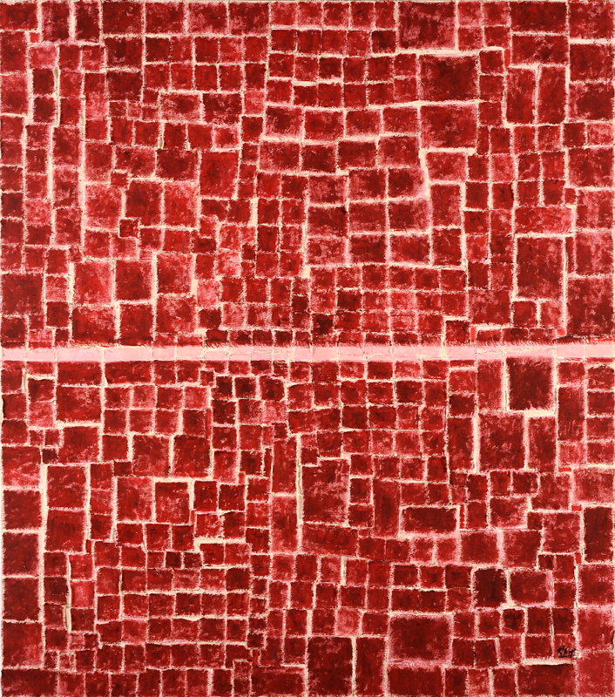

Roberto Diago: Entre Lineas | Between the Lines
September 6 – October 13, 2012
Opening Thursday, September 6th 6-8PM

Magnan Metz Gallery is pleased to announce the New York debut for Cuban artist, Juan Roberto Diago Durruthy. For his first US solo exhibition, Entres Lineas | Between the Lines, Diago will present new abstract works of richly textured canvases. The exhibition will be on view from September 6 - October 13, 20012.

Known for interweaving elements of his Afro-Cuban roots and involvement with the Abakua (a religious male secret society), Diago addresses issues of race, slavery and religion in his artwork. He figuratively incorporates both historical and contemporary references through a variety of materials such as canvas, bamboo and recycled materials in collages, the use of text and religious symbols bringing subjects of the past into today.
Entre Lineas | Between the Lines is a departure from the more obvious figurative references. This new body of work is stripped of its narrative, diluted into lines and planes of textures and colors. Diago employs a more universal code to address the world of his ancestors. He explains, “I stayed with the patches, seams, flat color and lines. Patches, pieces of fabric attached to form a collage that speaks of life broken, scattered and then reunited by resistant seams. The seam that joins all the good and bad, all the experience gained in this short journey of life... For me Entre Lineas | Between the Lines is a new experience to show another way of seeing, closer to the ancestors who continue walking with us in this wonderful journey we call life.”
This minimal, abstract style is evident in works such as the triptych, La fuerza de tu ser | The Strength of Your Being (Mixed media on canvas, 67 x 59 in [170.2 x 149.9 cm]), an allegory of Shango, the holy warrior diety representing male power and sexuality with his own lightning red dress. The red and black spots in the works titled Numero 11, Numero 12, and Numero 13 (Mixed media on canvas, 78 3/4 x 59 in [200 x 149.9 cm]) speak of Elegua, the guardian of the crossroads of life – where the holy roads open. And Paz en mi cabeza I and II (Mixed media on canvas, 118 1/8 x 78 3/4 in [300 x 200 cm] and 67 x 59 in [170.2 x 149.9 cm]) are an interpretation of Obbatalá, saint of peace and harmony among men. Although acknowledging these influences and signs within the artwork, Diago welcomes the viewer to interpret the work through their own experiences and interpretations – reading between the lines is in the eye of the beholder and their vision of the world we live in.
Diago graduated from the Academia de Artes Plásticas San Alejandro, Havana in 1990 and is a member of the Unión de Escritores y Artistas de Cuba (UNEAC). He has exhibited internationally and most recently particpated in the 2012 Havana Bienal, Queloides at the Mattress Factory, Harvard University and The 8th Floor. He was awarded the Juan Francisco Elso Prize by the National Fine Arts Museum, Cuba.
For more information or images please contact the gallery at info@magnanmetz.com or 212-244-2344

